# **Oops,filehandling,exception handling,modules**

Oops:

Main concept of oops is to bind the data and the function that work on that together as a single unit so that no other part of the code can access the data.

Class,object,polymorphism,encapsulation,inheritance,abstraction

Class:

collections of objects,

contains blueprint/prototype from which the objects are being created.

Logical entity that contains some attributes and methods.

Object:is an entity that has a state and behavior with it.(real world entity).

Self:class methods must have an extra one parameter in the method,we don’t give value to this python provides it.

Init:method runs as soon as an object of a class is instatiated.

To call the class attributes:

Obj1.__class__.attr1

To access instance attributes:

Obj.attr1

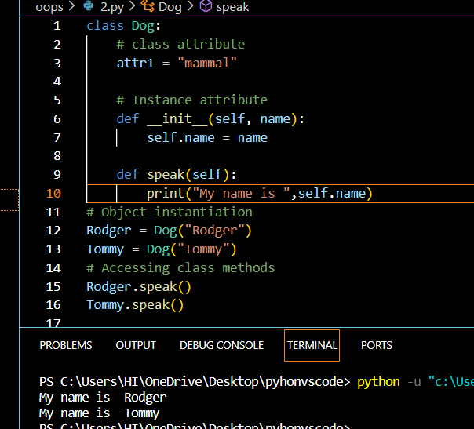

Encapsulation;

Wraapping data and methods that work on data within one unit class to prevent accidental modifications of data.

Protected members:cannot be accessed outside the class but can be accessed within the class and subclass(_)

Private members:class members declared private should neither be accessed outside class nor by any base class.

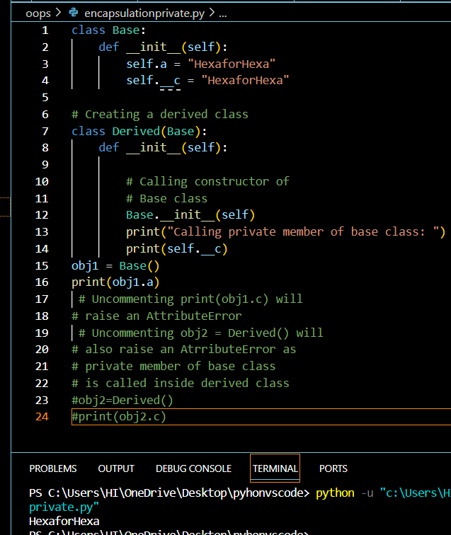

Polymorphism:

Having many forms ,same function name being used for different types

Difference is the datatype and number of arguments used In the functions.

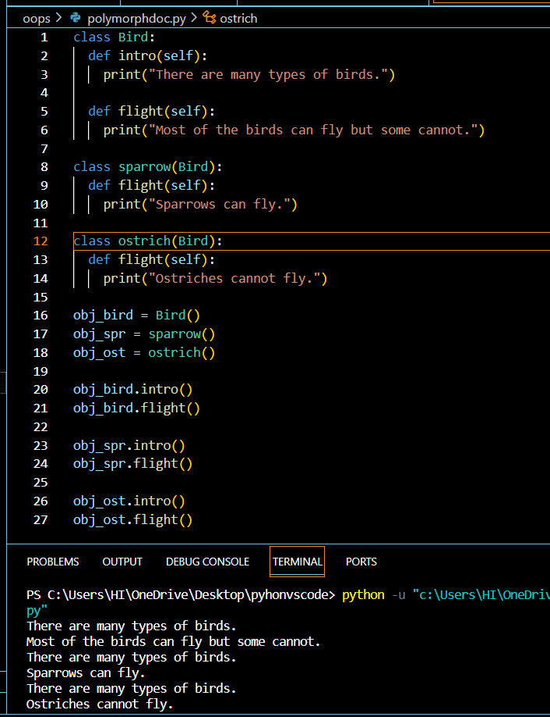

Method overriding:process of reimplementing a method in child class if it is not satisfied with the method in base class.Method in subclass overrides the method in base class .

Inheritance:

Capability of one class to derive or inherit the properties from another class

Reusability ,add more features,transitive.

Single

Multilevel

Multiple

Hierarichal

Hybrid

Single inheritance:

The properties of base class is inherited by child class.

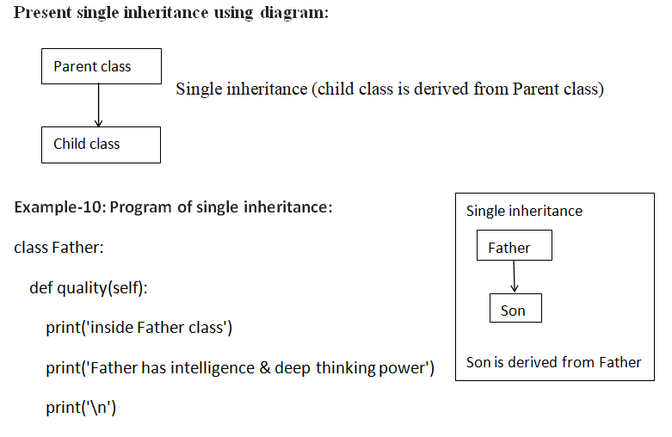

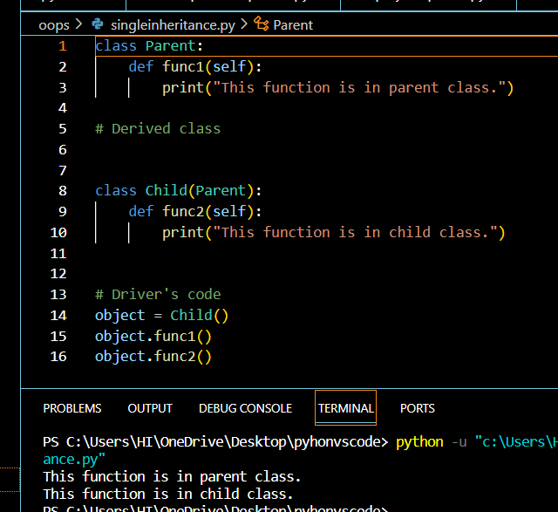

Multilevel:

Multiple:

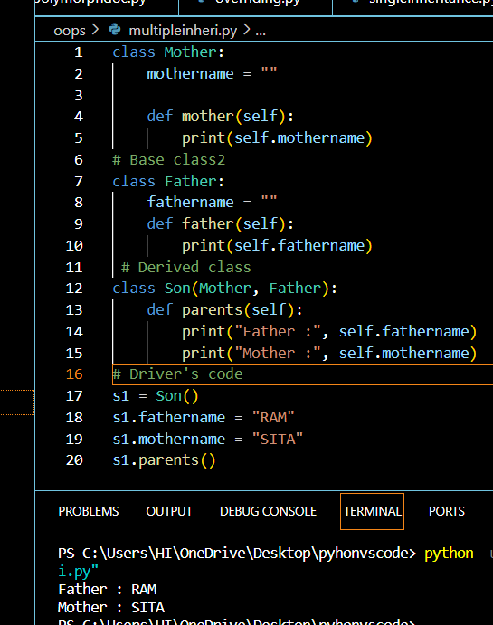

Hierarichal:

Hybrid:

Multiple+multilevel

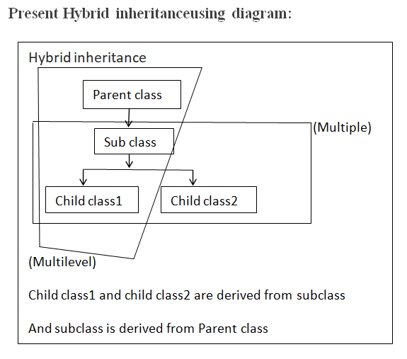

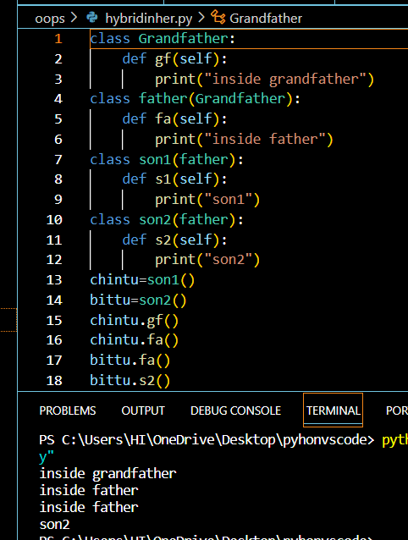

File handling:

Open the python file with open(filepath,mode)

Initialize this with a python object.

File=open(filename,r)

File.read():read will read content from the file into memory of the pythons object.

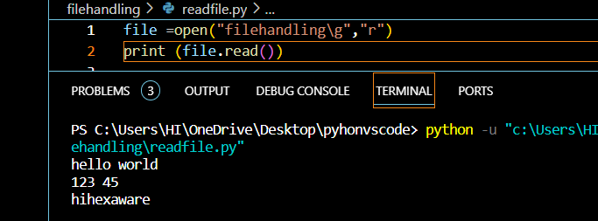

Converting the strings int lists or splitting the lines using splitlines:

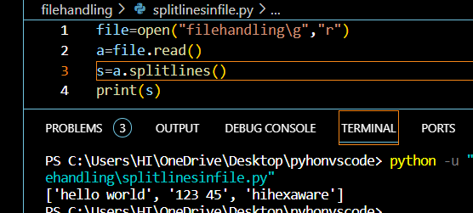

Write:

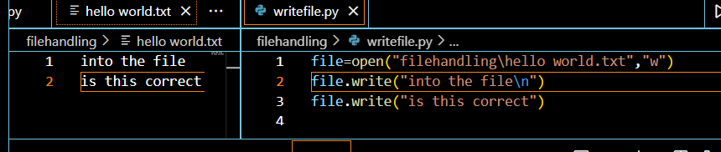

Append:

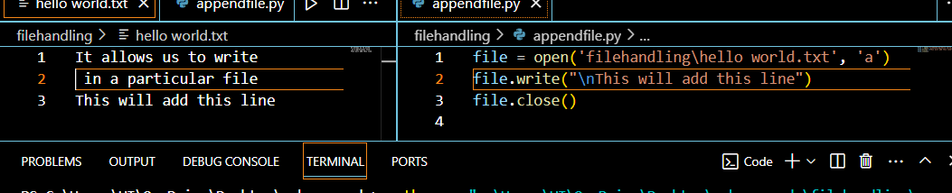

Exception handling:

The requirement for handling exceptions in Python arises when an error occurs that can cause the program to terminate. Errors interrupt the flow of the program at the point where they appear, so any further code stops executing. This error is called an exception.

Try ,except:

Statements that can raise exceptions are kept inside try clause

Statements that handle exceptions are kept in except clause.

If the statements in the try clause throws an exception then it is handle by except clase ,we can have any number of except clauses.

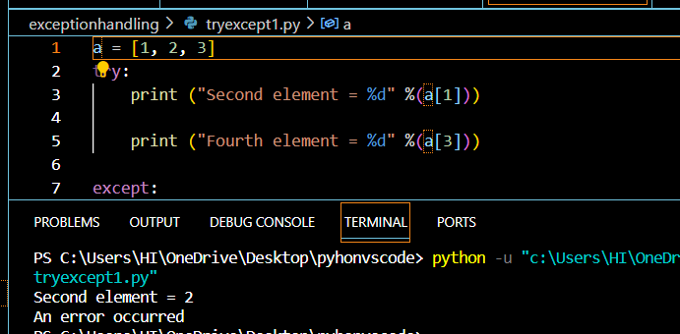

Try with else:

Code enters else block only if the try clause doesnot raise an exception.

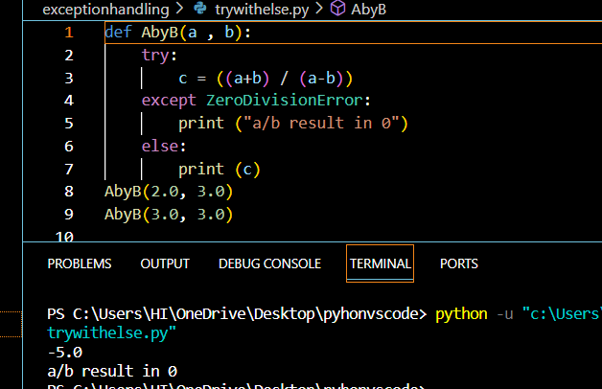

Finally:’always gets executed after try and except blocks

Raising exception:

Forcing a specific exception to occur.

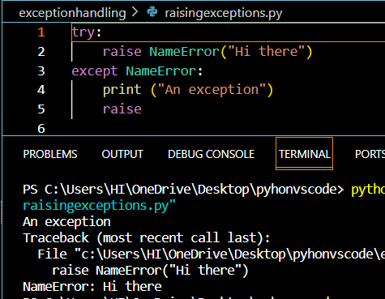

Modules:

Is a file containing python definitions and statements.

A module can define functions, classes, and variables. A module can also include runnable code. Grouping related code into a module makes the code easier to understand and use. It also makes the code logically organized.

Use dot operator to access the function inside the module.

sys.path is a built-in variable within the sys module. It contains a list of directories that the interpreter will search for the required module.

Math module:

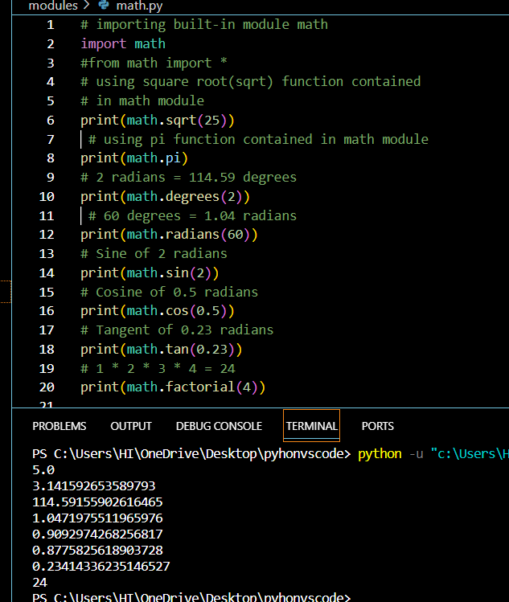

Creating our module:

First create a python file for contining the functions which is our module (ourmodule.py)

Next import the module using

Import ourmodule

Here we can import all components or particular components

from ourmodule import *

from ourmodule import a1

Next to access the functions in module we have to use . do operator

Ourmodule.functionname()